**VISVESVARAYA TECHNOLOGICAL UNIVERSITY**

**“JnanaSangama”, Belgaum -590014, Karnataka.**



**PROJECT WORK-1 REPORT**

**on**

**ONLINE FOOD STORE**

**(SWATO)**

***Submitted by***

**AMIT GUPTA (1BM20CS012)**

**AKSHATA MANJUNAATH NAIK (1BM20CS008)**

**AMBADAS. B (1BM20CS011)**

***Under the Guidance of***

**Dr. LATHA N.R**

**Assistant Professor, BMSCE**

***In Partial Fulfillment For The Award Of The Degree Of***

**BACHELOR OF ENGINEERING**

***in***

**COMPUTER SCIENCE AND ENGINEERING**



**B.M.S. COLLEGE OF ENGINEERING**

**(Autonomous Institution under VTU)**

**BENGALURU-560019**

**Oct-2021 to Feb-2022**

**B. M. S. College of Engineering,**

**Bull Temple Road, Bangalore 560019**

(Affiliated To Visvesvaraya Technological University, Belgaum)

**Department of Computer Science and Engineering**



**CERTIFICATE**

This is to certify that the project work entitled“**SWATO**” carried out by **AMIT GUPTA**

**(1BM20CS012), AKSHATA MANJUNATH NAIK (1BM20CS008)** and **AMBADAS. B (1BM20CS011)**who are bonafide students of **B. M. S. College ofEngineering.** It is in partial fulfillment for the award of **Bachelor of Engineering in Computer Science and Engineerin**

of the Visveswaraiah Technological University, Belgaum during the year 2021-2022. The project report has been approved as it satisfies the academic requirements in respect of **Proje**

**ct Work-1 (19CS3PWPW1)** work prescribed for the said degree.

Signature of the Guide                 Signature of the HOD

Dr. LATHA N.R Dr.JYOTHI S.NAYAK

Assistant Professor Associate Prof.& Head of Dept. of CSE

BMSCE, Bengaluru BMSCE, Bengaluru

External Viva

Name of the Examiner                                                                                  Signature with date

1._____________________________ ________________________

2. _____________________________ _________________________

**B.M.S. COLLEGE OF ENGINEERING**

**DEPARTMENT OF COMPUTER SCIENCE AND ENGINEERING**



***DECALARATION***

We,**AMIT GUPTA (1BM20CS012), AKSHATAMANJUNATH NAIK (1BM20CS008),** and **AMBADAS.B(1BM20CS011)** , students of 3rd Semester, B.E, Department of Computer Science and Engineering, B. M. S. College of Engineering, Bangalore, here by declare that, this Proj ect Work-1entitled "SWATO" has been carried out by us under the guidance ofLATHA N.R , Assistant Professor, Department of CSE, B. M. S. College of Engineering, Bangalore during t -he academic semester Oct-2021-Feb-2022

We also declare that to the best of our knowledge and belief, the development reported here is not from part of any other report by any other students.

Signature

**AMIT GUPTA(1BM20CS012)**

**AKSHATA MANJUNATH NAIK (1BM20CS008)**

**AMBADAS. B(1BM20CS011)**

1. Introduction

Website development for Online Food Application named as “SWATO”

**1.1 ABOUT THE WEBSITE**

This Website system is for all customers users.

Our website allows customers to get information about thevarities of food and healthy food.

**1.2FUNCTIONALITIES-**

* LoginPage:

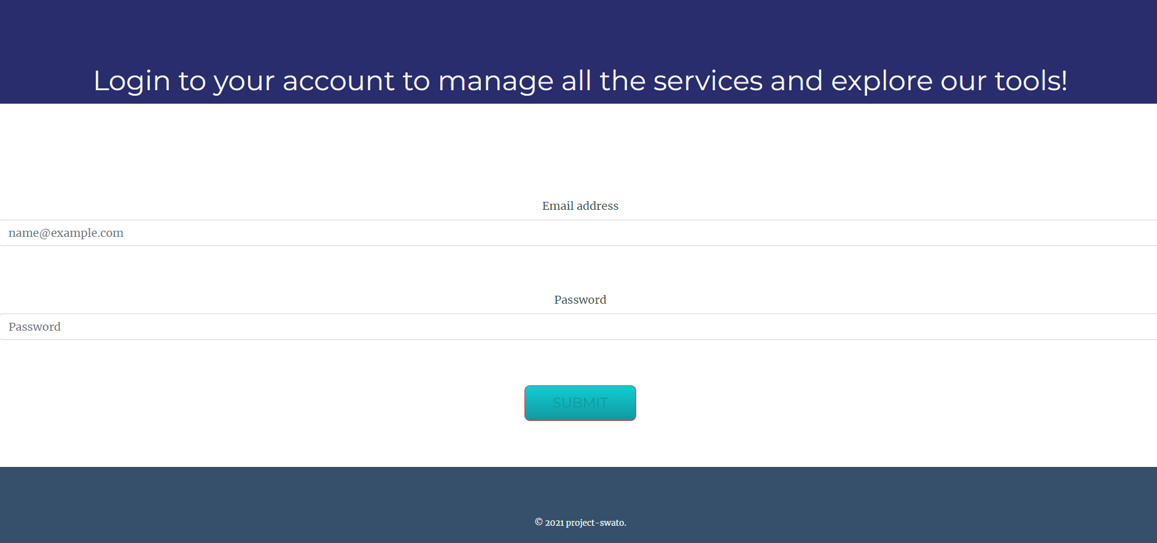

The user has to first register before logging in.Once registered, the user will have to provide proper email and password so they’ll be redirected to the menu page.

* Sign up for an account-

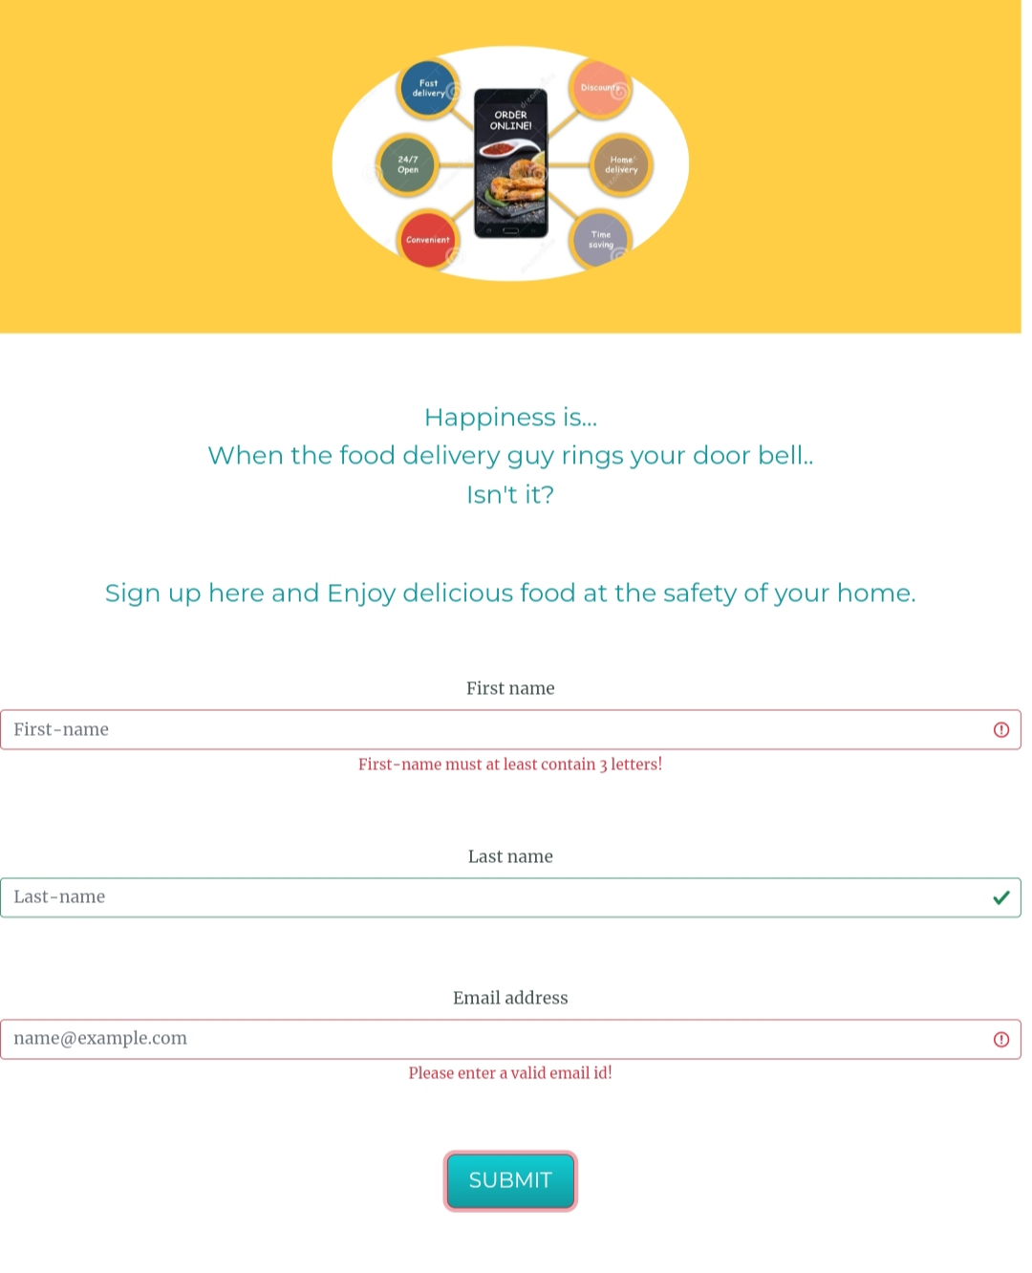The user will have to provide the first name, last name ,email address, password and confirm password for registering. The user will also have to verify the password. If the verification does not match, the user won’t be able to sign up.

* Home Page-

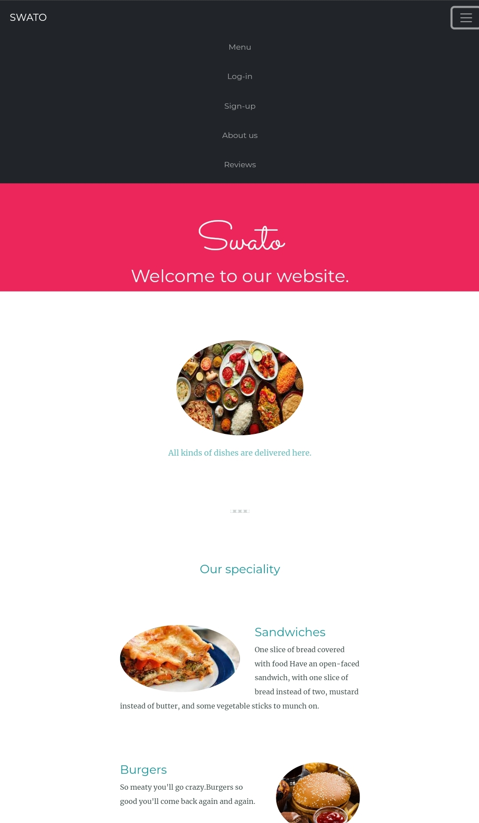

The home page is designed for the user to know about our specialityof food and also different dishes. From here the customers can login ,sign up and also they can see information about us.

* Menu Page-

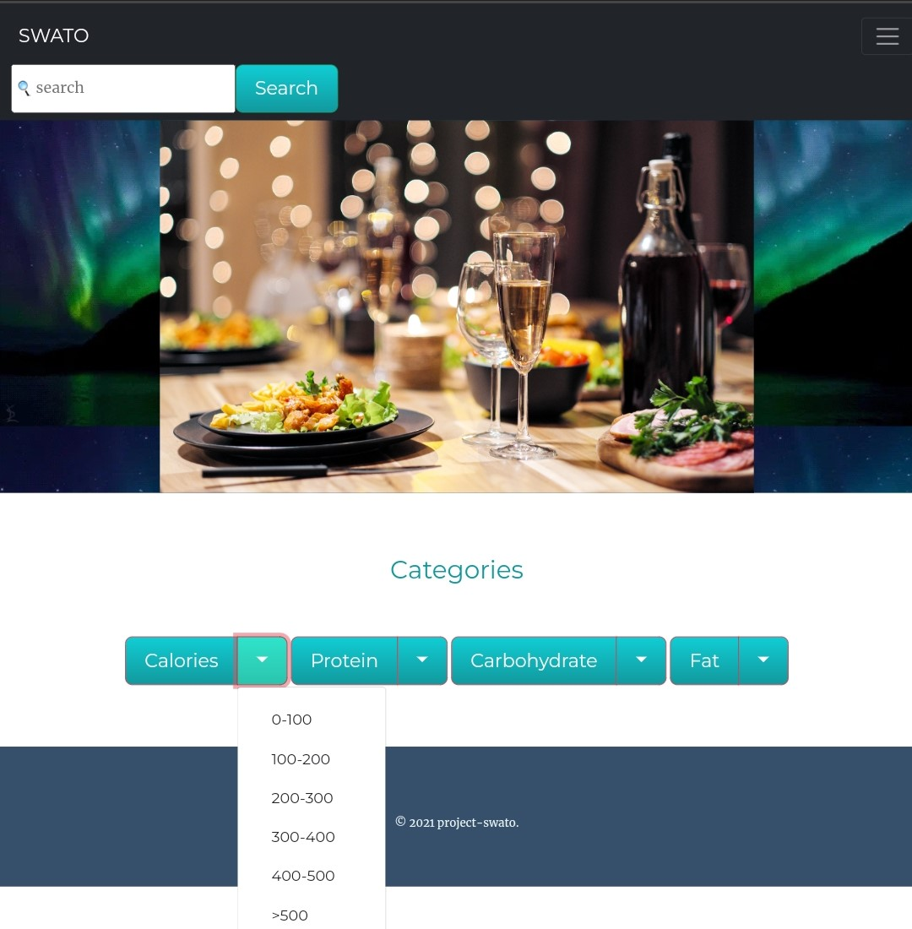

This is the menu page, where the user can select the different categories that are given above in picture. so the user can select the food accordingly to their health and this menu is also helpful for diet people, patient ,etc. and those item which are not available in this menu they can also even search the item from the search option at top left corner.

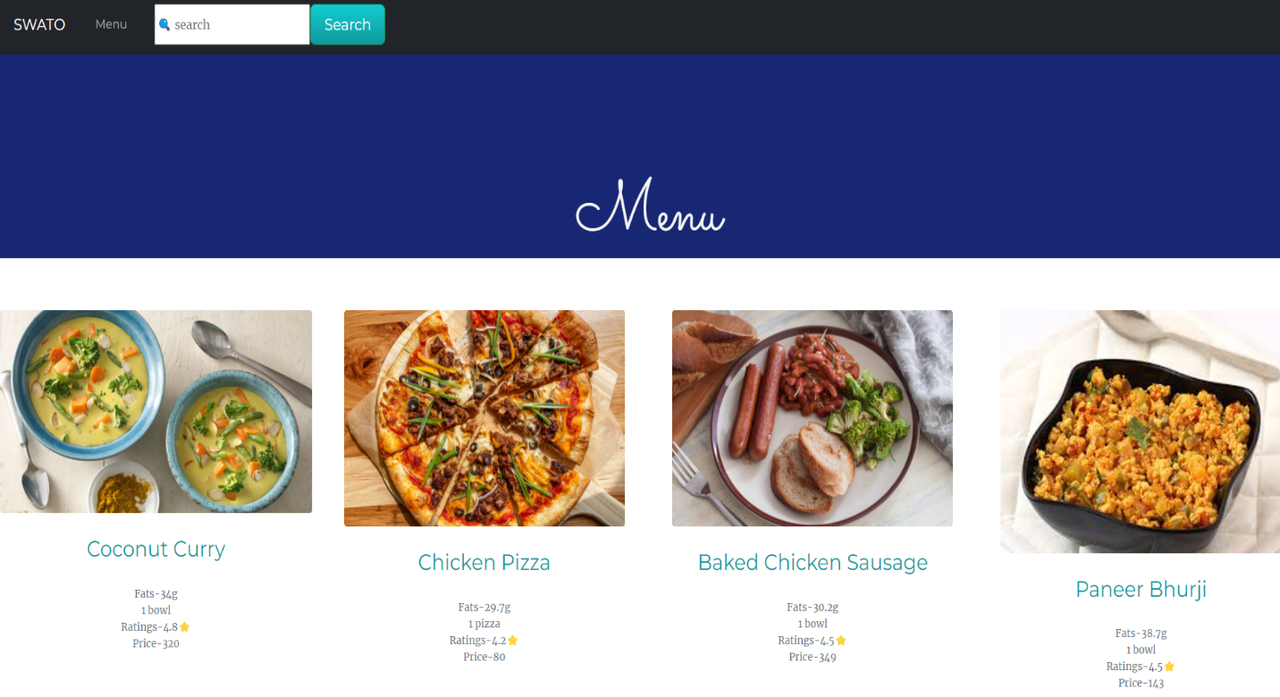

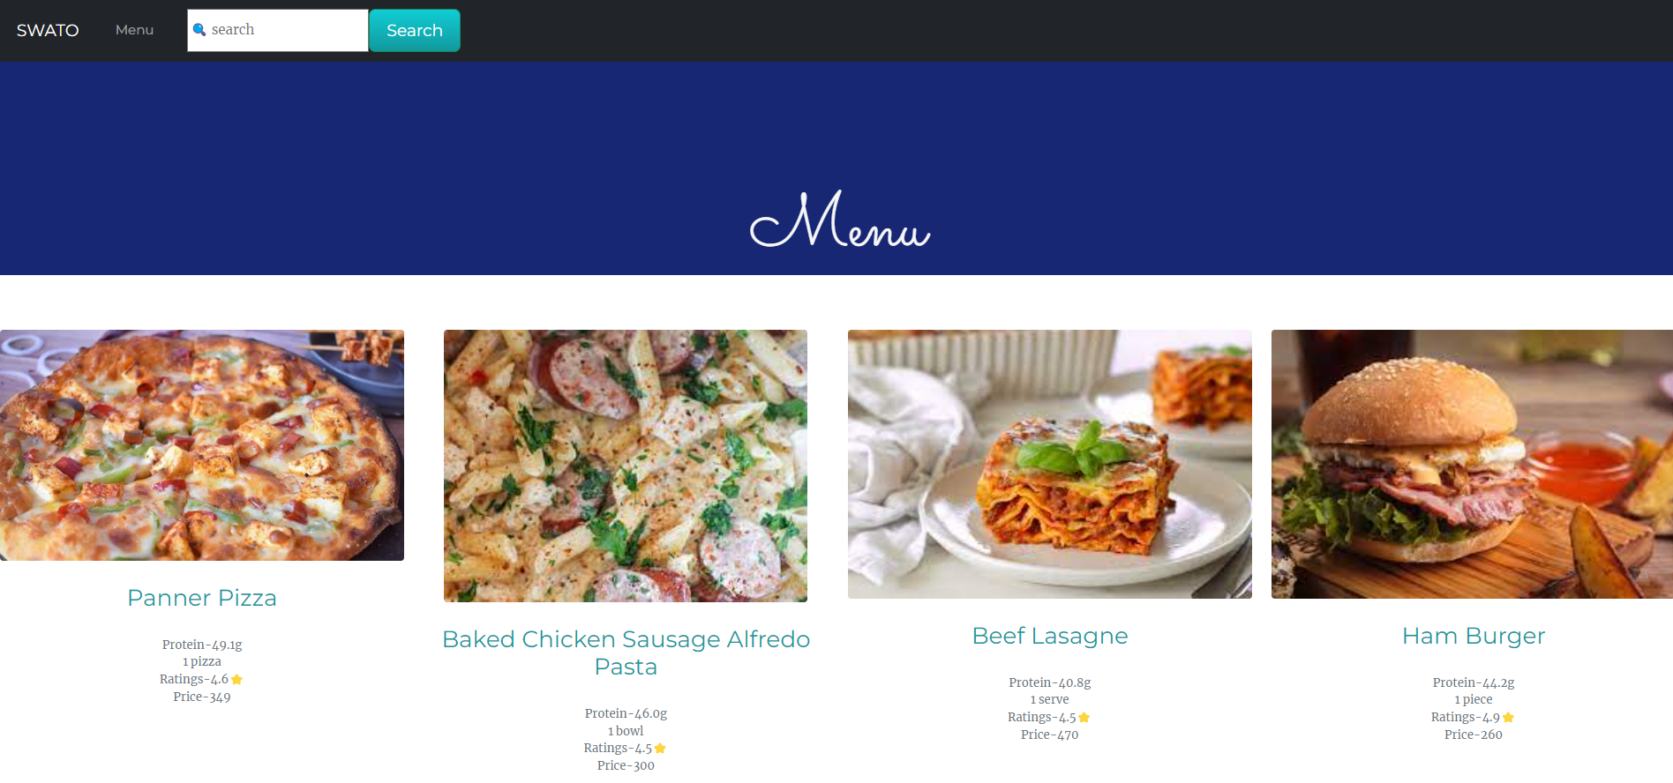

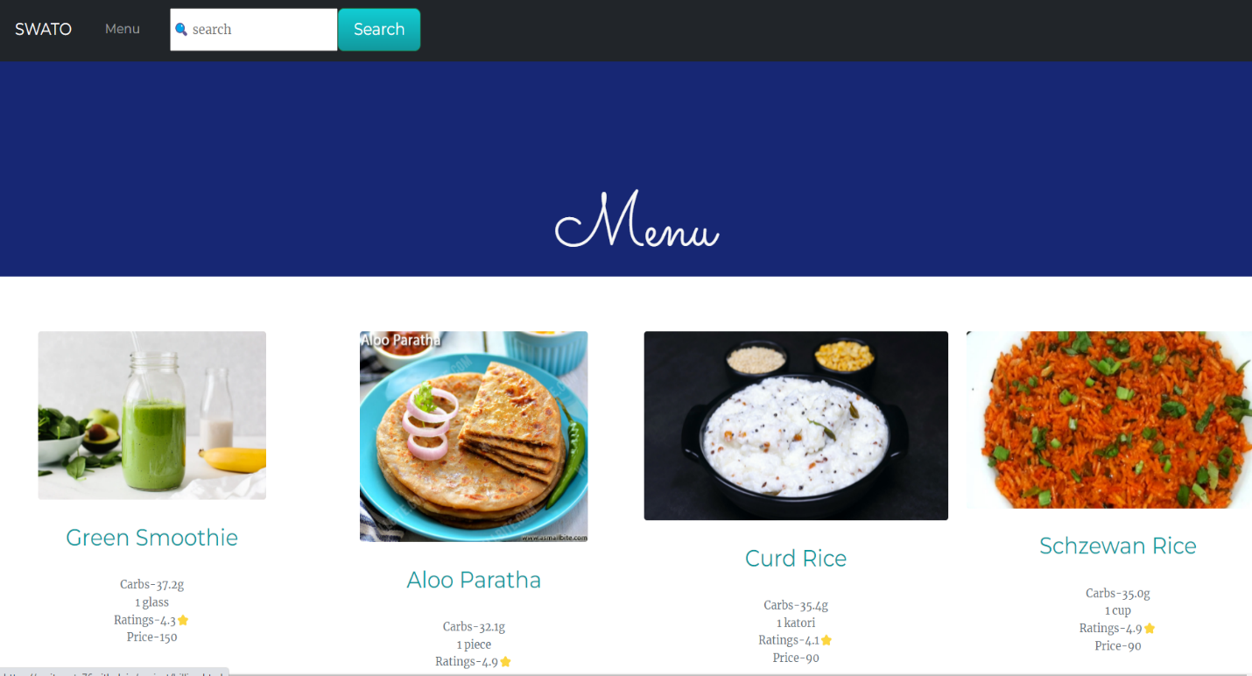

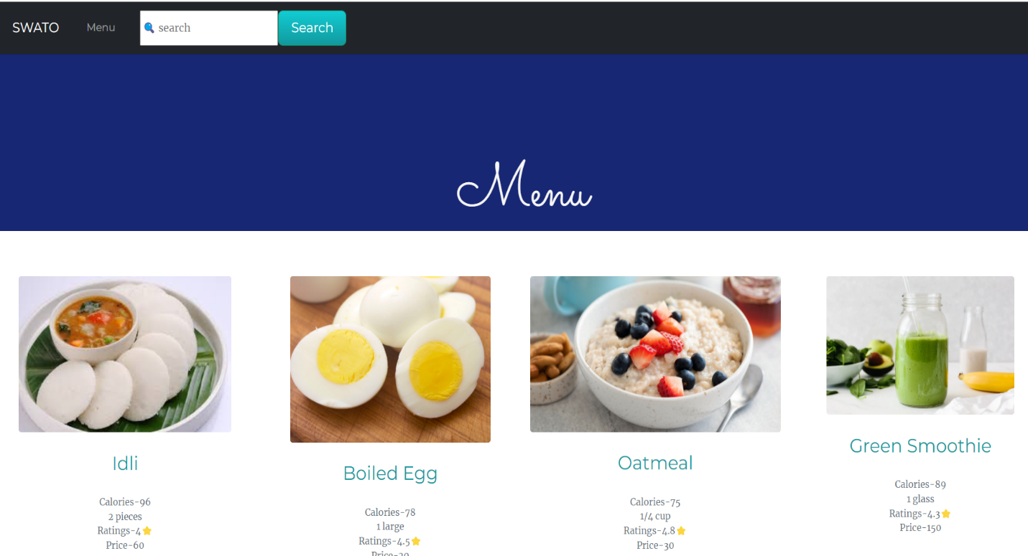

* This are some content of the Menu .Here the user can select the food item according to categories.

Contact us-

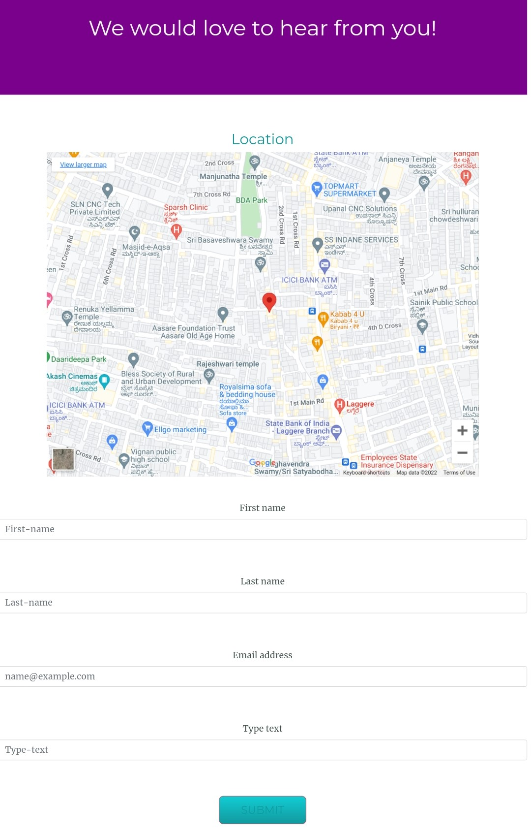

The Contact-Us page is designed with the intent to provide the user an option to contact us regarding issues, doubts about submission or other queries/questions or if the user needs assistance for orderingfood items or any assistance for that matter that we can assist the user.

About us-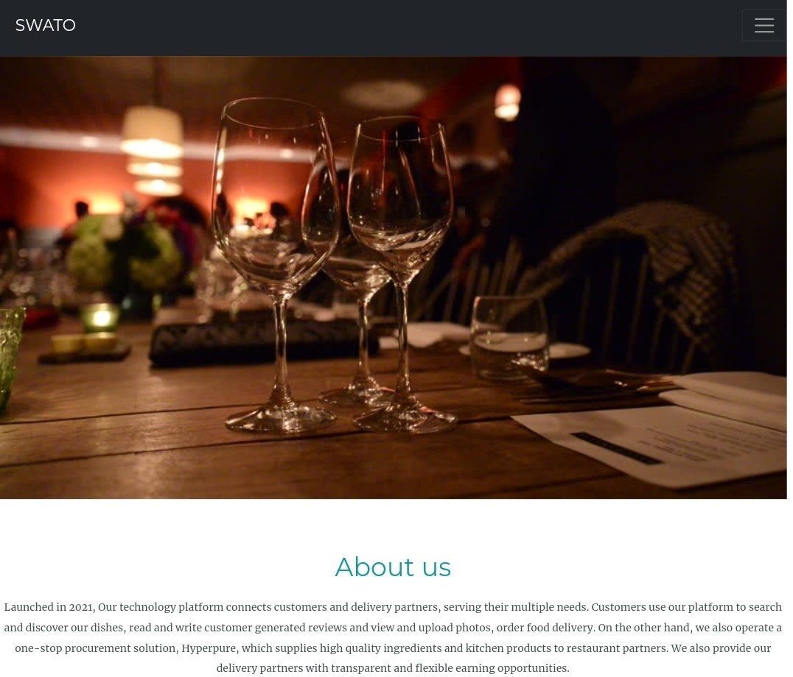

This page provides the information about website and food.

* **Review page-**

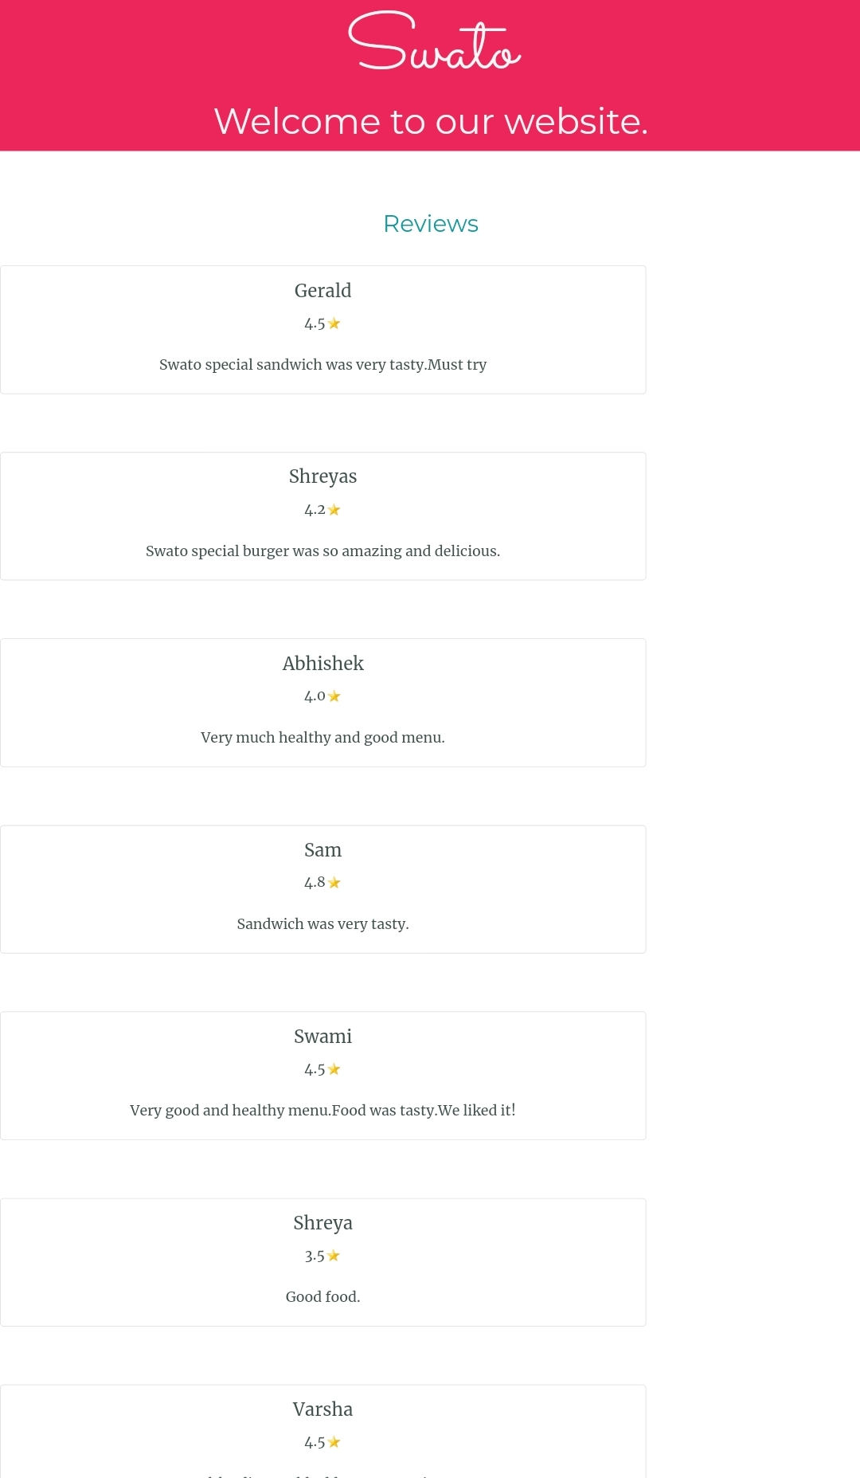

This review page is designed for the customers to see the reviews and ratings of this website

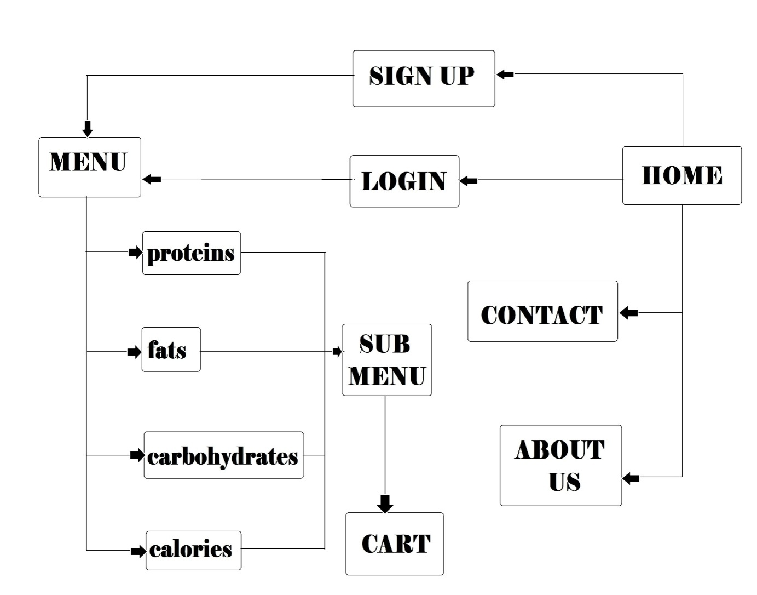• PROJECT LAYOUT-

• SOURCE CODE LINK:

The following link directs you to the GitHub repository which contain the source code to all of the above-mentioned webpages.

https://github.com/Amitgupta76/project